|  |
| --- |
| JKUAT  Domo Chat App |
| Design and Documentation |
| NAME: MUTIE NZANGI  UNIT: BCT 2402  UNIT NAME: CLIENT SERVER  REG NO: CS282-0778/2011 |
|  |
|  |
| **4/25/2015** |

|  |
| --- |
|  |

Contents

BACKGROUND 1

Requirements; 1

Functional requirements 1

Development tools 1

Specifications; 1

Use case diagram 2

Log in form for users: 2

# BACKGROUND

Domo chat is a windows form desktop chat application that enable people connected to each other to communicate inform of sms. The communication is real time therefore the application promote more of socialization between connected nodes.

# Requirements

## Functional requirements

* This system will allow a user to login in order to give a self-identity of the name to be displayed in the chat group.
* The system simplicity by having an easy to use GUI.
* The system allows users to delete messages and block friends they do not want to view their messages.

## Development tools

* Visual studio 2012

# Specifications;

System users;

* Client (desktop-user)

Responsibilities;

* Login to the system
* View a list of online users
* Block a friend from his/her account
* Delete messages.
* Terminate a chat session from a group.

## Use case diagram

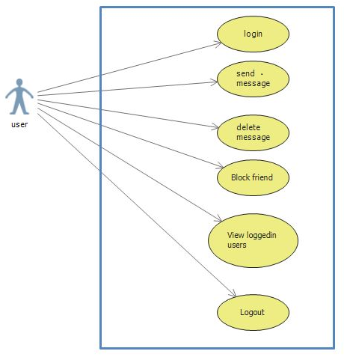

# Log in form for users:

Created using C#. It allows a user to login in order to chat.

It has two textboxes where to input the Name (the name to be displayed in the group after a login), chat group name (Maps to a specific ip address for connection to allow chatting).

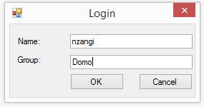

The ok button of the login form is initially set to “enabled = false”.

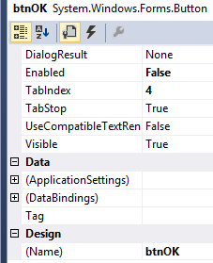

If the name textbox is empty the ok button remains disabled even if the group name is right.

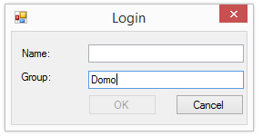

Also in the case we have the name textbox not empty but the group name textbox empty, the ok button remains inactive.

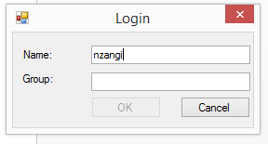

If the name textbox is not empty but the group name is not domo, a wrong group name messagebox message is given.

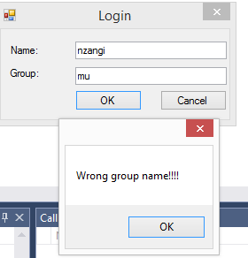

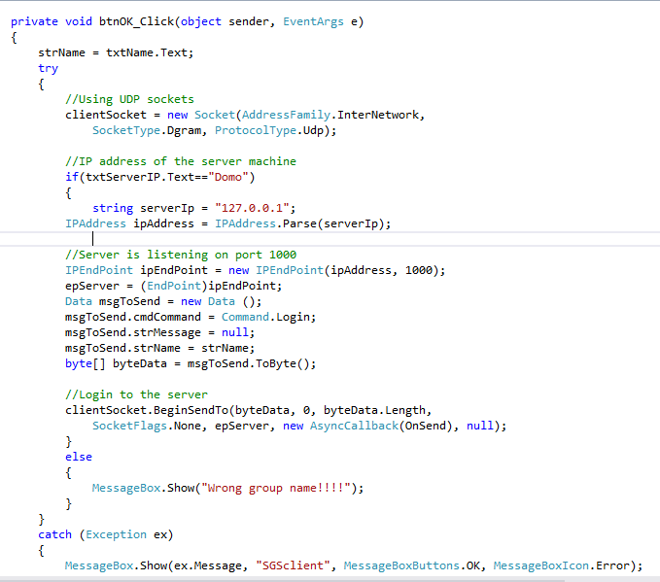

On a successful login (the name textbox is not empty and the group name is Domo); a connection to the server is established and one is taken to the main chat form if a connection to the server is established.

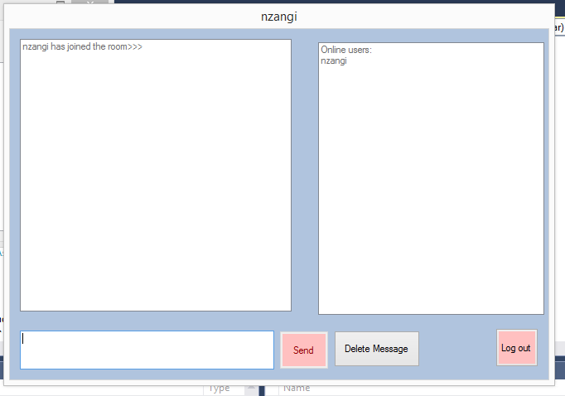

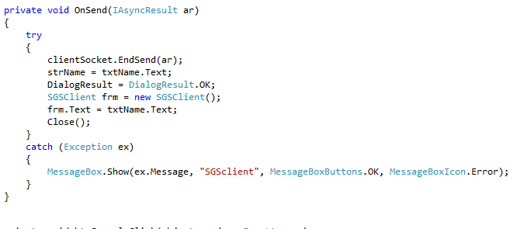

The server is also a windows form which on starting it displays a server started message. It creates a socket and set on a listen mode and accept incoming connections. It also a list box to display all the ip addresses of the machines connected through it.

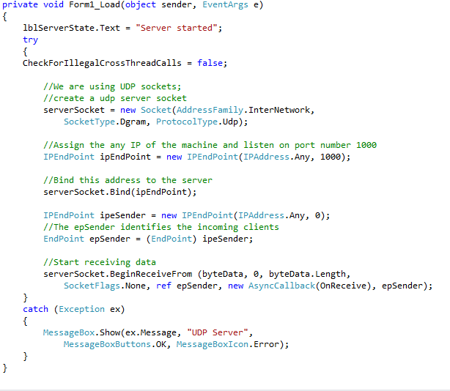

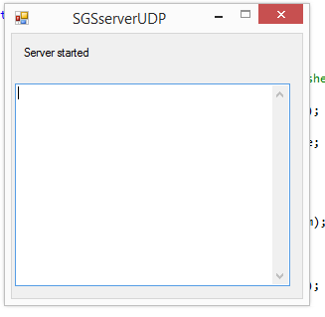

After login the computer a user join message is send to all online nodes in the group after which one is good to start a chat and his name added to the list of logged in users is added to every user’s online users listbox.

**Server side code**

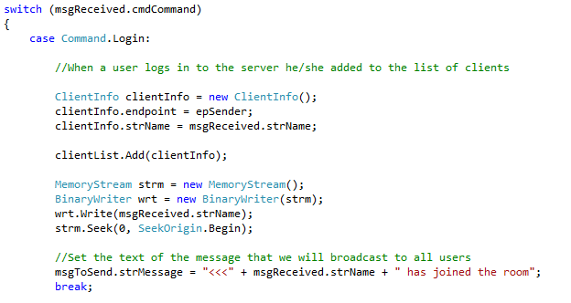

**Server side code**

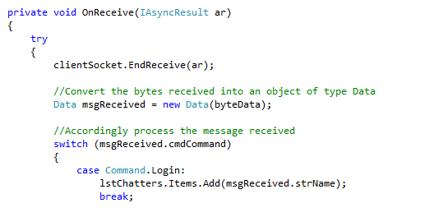

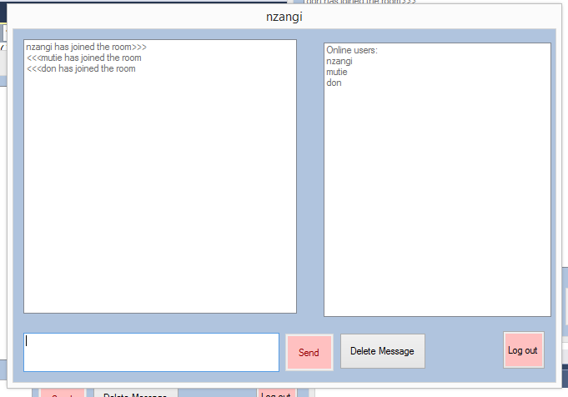

Once logged in, one to send message has to type in the message textbox and click on the send button. This messege is send through the sock and broadcasted to all online users.

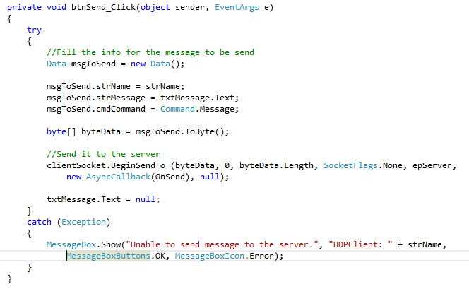

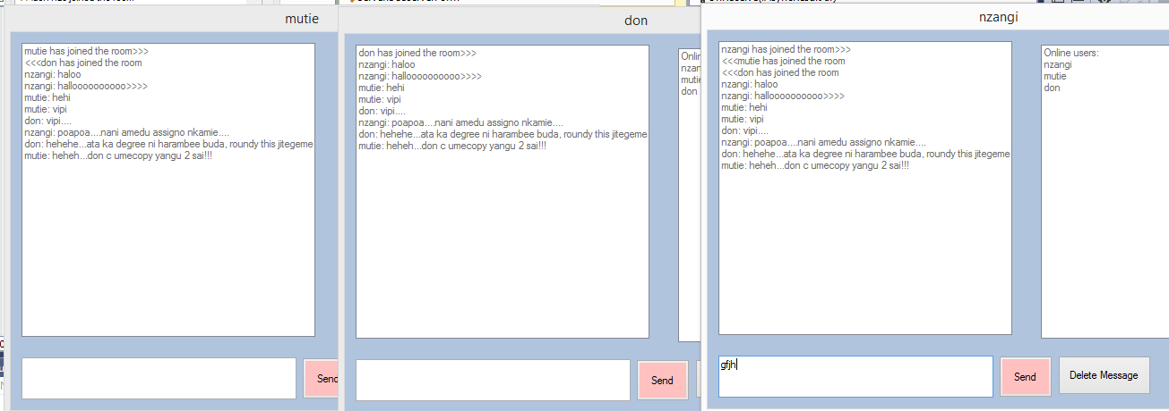

The application also enable a user to delete to delete message(s) by clicking the delete message button afterwhich one through you click the done button.

**Delete button**

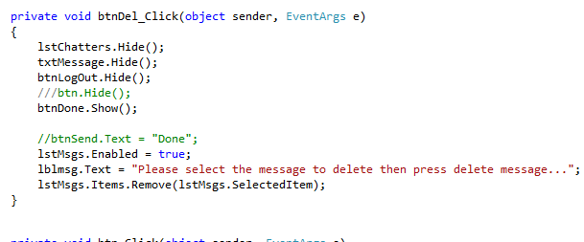

**Done button**

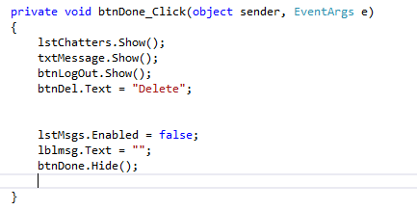

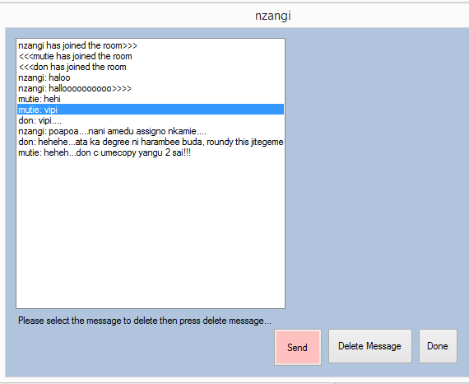

The additional functionality provided by the domo chat application is logout a user to terminate a chat. On clicking the logout button, a dialogbox to confirm loging out is displayed from which on clicking ok the connection with user is terminated and a user logout message broadcasted to all other connected users.

**Server side**

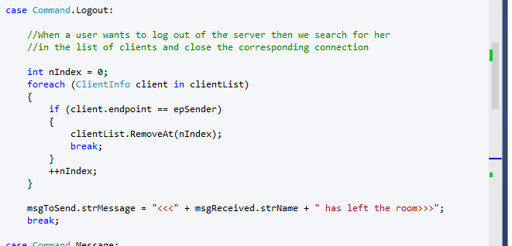

**Client side**

**Close method**

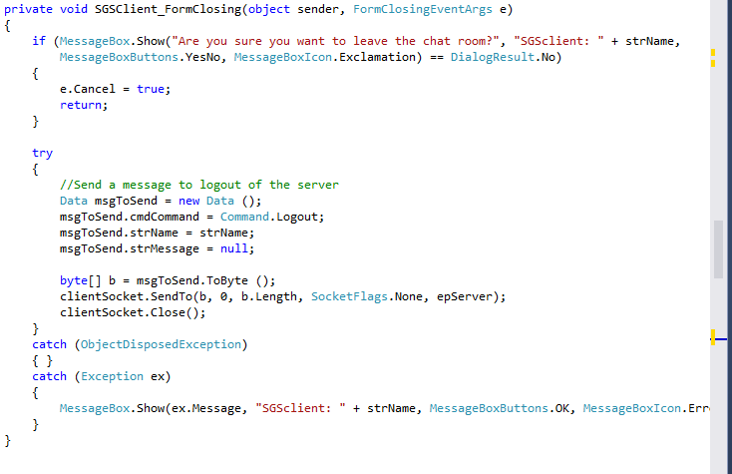

**Logout method click**

